Religion, Values and Ethics E-magazine: June 2022
Title: Special Places

Titles | Paganism and Places of Inspiration | Islamic Pilgrimage to Mecca | Anglo Catholics Pilgrimage
Logic | DISCLAIMER: The Teachers' Notes have been updated so that the resource can be used through Curriculum for Wales. However, the content of the articles has been archived and the information has not been updated. The articles are kept on the website as the content is still relevant to Curriculum for Wales: Religion, Values and Ethics.  The four purposes of 'Curriculum for Wales - A curriculum for life'  By learning about Special Places in their Religion, Values and Ethics education lessons, there will be opportunities for learners to develop [as/into]:  • Ambitious, capable learners who can explain the ideas and concepts they are learning about;  • Healthy, confident individuals who have secure values and are establishing their spiritual and ethical beliefs;  • Enterprising, creative contributors who give of their energy and skills so that other people will benefit;  • Ethical, informed citizens who engage with contemporary issues based upon their knowledge and values.  RVE in The Curriculum for Wales  By reading and using the articles in their Religion, Values and Ethics lessons, learners will have opportunities to:  - Engage with and explore ultimate and philosophical questions  - Undertake enquiries and engage with sources of wisdom and philosophies  - Develop and express their own informed viewpoints  - Use their knowledge and understanding of religious and non-religious worldviews to think critically about their own values  - Explore the ways in which religion and non-religious philosophical convictions have influenced human experience throughout history  - Evaluate and use evidence from a range of religious and non-religious sources to engage with ethical and moral issues  - Explore the beliefs and practices of the people in their community, Wales and the wider world and respond sensitively to them  - Develop secure values and establish their own ethical beliefs and spirituality  - Discuss and reflect on their own perspectives and those of others  The RVE lens  By reading and using the articles in their Religion, Values and Ethics lessons, learners will have opportnities to explore a range of RVE concepts through the sub lenses below:  • Search for meaning and purpose;  • The natural world and living things;  • Identity and belonging;  • Authority and influence;  • Relationships and responsibility;  • Values and ethics;  • The journey of life;  *Please note that RVE is locally determined through an agreed syllabus. Each local authority has its own agreed syllabus for RVE that schools must have regard to. All agreed syllabi have had regard to the Curriculum for Wales framework and RVE guidance referenced above and below.  Useful Links:  The RVE Guidance - https://hwb.gov.wales/curriculum-for-wales/humanities/designing-your-curriculum/#religion,-values-and-ethics-guidance  Hwb Humanities Guidance - https://hwb.gov.wales/curriculum-for-wales/humanities  Statements of What Matters - https://hwb.gov.wales/curriculum-for-wales/humanities/statements-of-what-matters/  Cross-cutting Themes - https://hwb.gov.wales/curriculum-for-wales/humanities/designing-your-curriculum/#cross-cutting-themes
Key Words | Paganism - an umbrella term for many different traditions that are closely linked to their environment in terms of history, geography, culture and myths.  Inspiration – the process of being mentally stimulated to do or feel something  environment – the world around us  Polytheism – the belief in more than one god  Pantheism – the belief that god is everything and in everything  Culture– things that influence how we live and behave e.g. history, values.  Awen - the creative force that flows through nature  Deity – a god or goddess in a religion  Druids - A druid was a member of the upper class in ancient Celtic cultures. Druids were religious leaders as well as legal experts, adjudicators, doctors and political advisers. The Druids left no written records.  Barclodiad y Gawres - a neolithic burial chamber in Anglesey  Ancestors – people from the past  Relics – objects from the past  Neolithic – a period in History about 6000 years ago  Summer solstice – longest day of the year – 21 June  Winter solstice – shortest day of the year – 21 December | Islam - one of the 6 largest religions of the world  Muslim- An individual who follows Islam  Pilgrimage - A special religious trip  Hajj- A special journey within Islam  Mosque- A place of worship  5 pillars of Islam- 5 most important rules within Islam  Mecca- A city in Saudi Arabia  Ihram- A white dress that all men must wear to symbolize equality between everyone on the Hajj.  Ka'ba- A huge box in the Great Mosque that Muslims must walk around  Qur'an- The holy book of Islam  Significance- Something important  Duty - a task or action that someone needs to perform  Itinerary - a document showing the route/plan | Anglican - an adjective for anything relating to the Anglican Church; e.g. The Church in Wales / Church of England.  Catholic – an adjective for anything relating to the Roman Catholic Church.  Anglo-Catholic – an adjective for anything relating to both the Anglican and Catholic traditions.  Pilgrimage – to go on a journey to a place of religious significance.  Protestant Reformation – protest to reform the Roman Catholic Church in the 16th Century which led to the formation of various Protestant Churches.
Search words | Paganism  Religion  Environment  Myths  Traditions  Sacred  Inspiration  Druids  Neolithic  Anglesey  Bryn Celli Ddu  Burial chamber | Muslim  Islam  Hajj  5 pillars of Islam  Mecca  Ihram  Ka’ba  Qur’an  Mosque | Saint  Anglican  Catholic  Anglo-Catholic Pilgrimage  Devotion  Miracle  Miraculous
Extended Tasks

Classroom Tasks | 1. Think of a place that is special to you and try to explain why. Present a portrayal of that place to the rest of the class.  2. Investigate further Pagan sects and beliefs.  3. Why do you think Paganism appeals to so many people?  4. Investigate further the Pagan celebrations that take place at Bryn Celli Ddu or Stonehenge and write a blog giving your impressions of those celebrations.  5. Have a class discussion about whether Paganism should be considered as a religion.  6. Arrange a visit to one of the special places in Paganism or arrange for a member of one of the Pagan sects to visit the school. | - Create a poster in your book about everything you’ve learned about Islam. Remember to go back to your previous work for information!  - Answer the questions below in full sentences in your book  - Explain why Muslims wear an Ihram during Hajj.  - Can you name every place a Muslim will visit during Hajj?  - What is the title given to Muslims men and women after they finish Hajj?  - Where does Hajj take place? Name the country and the city.  - Can you list different pilgrimages we have looked at during this term?  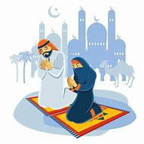  Create your own Islamic prayer mat in your book  Here is a template to help you!  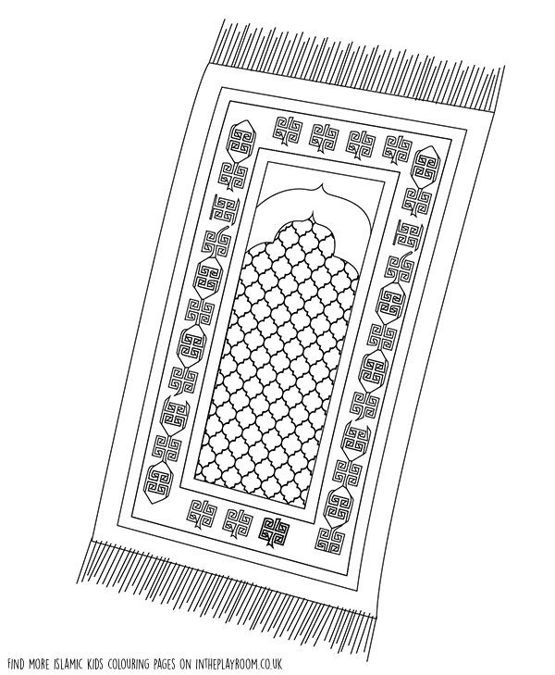 | - Make a collection of the names of important religious sites in Wales. Place the twelve most important on a map of Wales.  - Collect more information on Saint Winefride. Read about other saints, e.g. St.Dwynwen. Are there similar (and unfortunate) elements in these stories?  - Why has Holywell been describrs as ‘The Lourdes of Wales’? Make a table to show important features about both places in a way that shows their similarities and differences.  - Using the website http://www.penrhyspilgrimage.wales and others; present information on the 21 mile journey from Cardiff to Penrhys. Make a map to show some of the sites of interest along the route.  - What good work has been done by the community in Penrhys to improve the quality of life for people living there? Remember to refer to the contribution of Llanfair Church, Penrhys.  - ’Pilgrimage today is no more than a day out and a chance to socialise’.  Prepare a speech for and against this statement. You can work in pairs in order to present arguements on both sides.
Further resources

